Laptop Price Prediction

Team Members:
Team Leader: Karim Amr Abdelmonem
Second Member: Malak Mowaffak Shawky
Third Member: Omar Ali Hussien
Fourth Member: Youssef Albir Soliman
Fifth Member: Kirolous Ashraf Raouf

Member | Task
Omar Ali Hussien | Data Preprocessing and Analysis
Malak Mowaffak Shawky

Kirolous Ashraf Raouf

Karim Amr Abdelmonem | Modleing Validation and Tuning
Youssef Albir Soliman

Contents
1.0 Data Description and Model Purpose: 4
1.1 Key results 4
1.2 Conclusion 4
2.0 Data Exploration & Analysis (EDA) 5
Data Overview, Statistical Summary & Missing Value Analysis 5
Correlation Analysis 5
Central Tendency 6
3.0 Data Cleaning and Feature Engineering 6
One Hot Encoding 6
Structural transformation 7
4.0 Feature Selection and Dataset Preparation 7
5.0 Modeling Validation and Tuning 9
Learning Curve Analysis 10
Feature Scaling 10
Polynomial Regression (Degree 2) 11
Regularization (Ridge and Lasso) 11
Ridge Regression 11
Lasso Regression 11
Decision Tree Regressor 12
Multi-Model Benchmarking with Pipelines 12
6.0 Model Evaluation and Comparison 13
Evaluation Metrics 13
Observations 13
7.0 Hyperparameter Tuning 14
Ridge Regression Tuning 14
Polynomial Regression Tuning 14
Decision Tree Tuning 14
8.0 Final Model Selection 15

Laptop Prediction

1.0 Data Description and Model Purpose:
Our dataset contains detailed specifications for different laptops along with their market prices. It helps us understand how the technical features of a laptop relate to its real-world value. The dataset is divided into two parts: a training set of 881 laptops, where both the specifications and prices are known, and a testing set of 422 laptops used to evaluate how well the model performs.
Each laptop includes a wide range of hardware specifications such as CPU frequency, RAM size, and storage capacity. These are the kinds of features people usually look at when comparing laptops online or in stores.
In addition to internal hardware, the dataset also includes physical characteristics like screen size, screen resolution, and weight. Brand information is also included and categorized so the model can recognize differences between manufacturers.
The main objective of this project is to build a regression model that can accurately estimate the market price of a laptop based on these specifications.
By analyzing how different technical features influence price, the model helps highlight the key factors that determine laptop value—such as RAM size and processor speed. This allows us to create a data-driven approach to estimating laptop prices and understanding pricing patterns within the electronics market.

1.1 Key results
The final regression model demonstrated strong predictive performance when estimating laptop prices based on their specifications. During evaluation, the model achieved an R² value of approximately 0.81, which means it can explain about 81% of the variation in laptop prices within the dataset.
In addition, the Mean Absolute Error (MAE) remained within an acceptable range. This indicates that, on average, the difference between the predicted price and the actual market price is relatively small.
Overall, these results show that the model performs reliably and is capable of providing realistic price estimates for a wide range of laptop configurations.

1.2 Conclusion
The analysis shows that certain technical specifications play a major role in determining laptop prices. In particular, RAM capacity and CPU speed were found to have a strong positive relationship with price. As these specifications increase, laptop prices tend to rise as well.
Laptop category also plays an important role. Devices classified as Gaming laptops or Ultrabooks tend to be more expensive because they usually include specialized hardware such as powerful graphics cards and high-performance processors.
On the other hand, features like screen size were found to have a weaker relationship with price. This suggests that buyers and manufacturers place greater value on internal performance components rather than just physical dimensions.
Overall, the results confirm that laptop pricing is driven mainly by internal hardware performance and storage technology rather than purely external features.

2.0 Data Exploration & Analysis (EDA)

Data Overview, Statistical Summary & Missing Value Analysis
The first step in our analysis was to explore the structure of the dataset. This involved checking the number of records, identifying the types of data in each column, and reviewing the overall statistical distribution of numerical variables.
By performing this initial inspection, we were able to understand the general range of laptop prices and hardware specifications within the training dataset.
Another important step was checking for missing values. We calculated the number of null entries in each feature to determine whether any data cleaning or imputation would be required before training our models. Ensuring that the dataset is complete and consistent is essential for building reliable machine learning models.
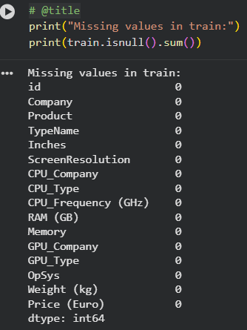

Correlation Analysis
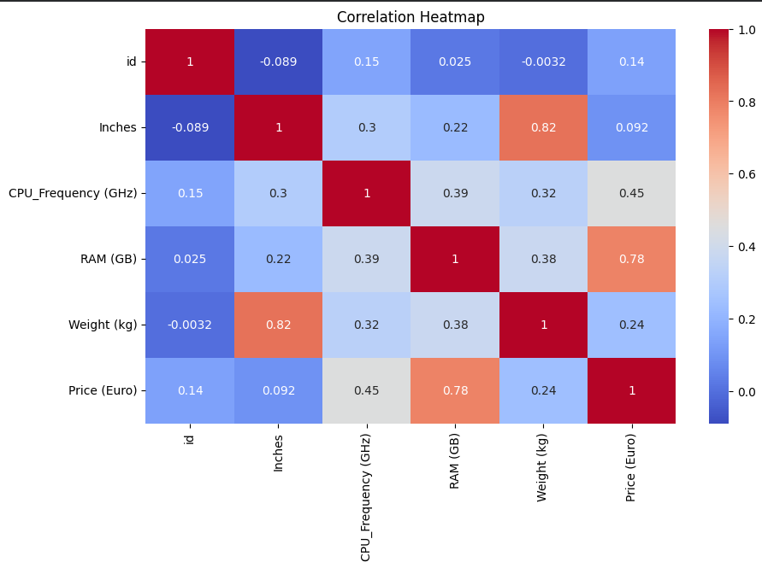
To better understand the relationships between different numerical variables, we generated a correlation heatmap. This visualization highlights how strongly different features are related to each other and to the target variable (price).
The heatmap revealed several important insights:
- RAM showed the strongest relationship with price, with a correlation coefficient of 0.74, indicating that laptops with more RAM are generally more expensive.
- A strong correlation of 0.82 was observed between screen size (inches) and weight, which is expected since larger laptops tend to weigh more.
This type of analysis helps identify which features are most useful for predicting price while also revealing cases where multiple variables provide very similar information.
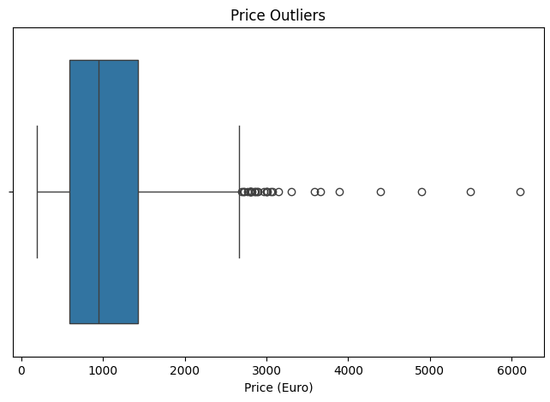
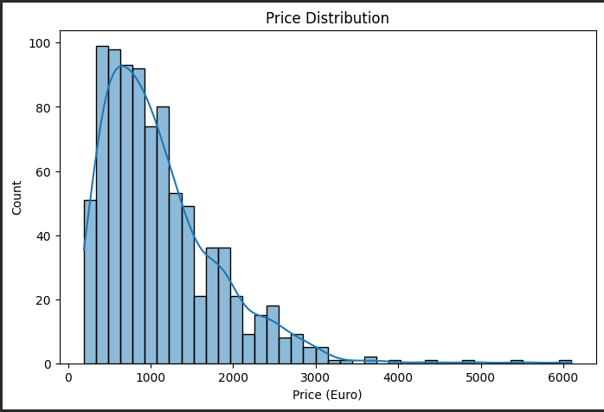
The price histogram showed a right-skewed distribution. This means most laptops in the dataset fall within the budget to mid-range price category, while only a smaller number of laptops belong to the high-end premium segment.
A boxplot visualization also revealed several outliers above €2,500. These likely represent premium or high-performance laptops that sit far outside the typical price range.

Central Tendency
Looking at the distribution of prices, the median price appears relatively low compared to the highest values in the dataset. This confirms that while a few expensive laptops exist, the majority of devices are priced in the lower to mid-range market segment.

3.0 Data Cleaning and Feature Engineering
Before applying any machine learning models, we prepared and cleaned the dataset to ensure it could be processed effectively.
To begin, we created a deep copy of the dataset so that all transformations could be performed without modifying the original data.
We then focused on handling missing values and ensuring that all numerical features were formatted consistently so the models could interpret them correctly.

One Hot Encoding
Several variables in the dataset were categorical (text-based), such as laptop brand or operating system. Machine learning models cannot directly process text values, so we converted these categories into a numerical format using One-Hot Encoding.
This process creates a separate binary column for each category. If a laptop belongs to that category, the value is 1; otherwise it is 0.
One-Hot Encoding was applied to the following features:
- Company Name
- Laptop Type
- Operating System
- GPU Company
- CPU Company
- Memory Type
After the new encoded columns were created, the original text columns were removed because they were no longer needed.

Structural transformation
Some features required additional restructuring so that they could be interpreted numerically by the model.
Screen Resolution Splitting
The original screen resolution column contained text values (for example: 1920x1080). We split this into two separate numerical columns:
- Screen Width
- Screen Height
This allows the model to analyze screen resolution directly as pixel counts.
Memory Conversion
Storage values originally appeared as text (for example: 512GB or 1TB). These values were converted into a consistent numerical format measured in gigabytes. This ensures that the model understands the true scale of storage capacity rather than treating the values as simple labels.
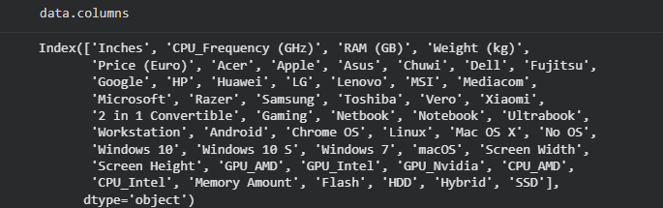

4.0 Feature Selection and Dataset Preparation
To determine which variables were most useful for predicting laptop prices, we performed feature correlation analysis.
The results showed several key relationships. For example, CPU Frequency (GHz) had a moderate positive correlation of 0.43 with price, suggesting that laptops with faster processors tend to be more expensive.
In contrast, screen size (inches) showed almost no correlation with price (approximately 0.068). This indicates that larger screens do not necessarily mean higher prices, and that internal hardware specifications have a much stronger influence on cost.
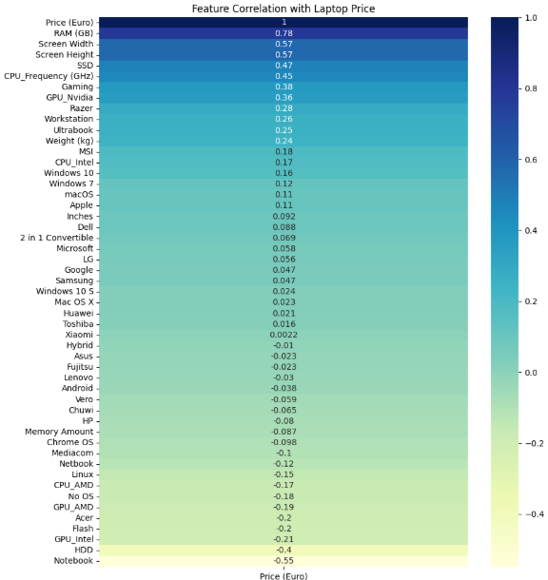
Based on this analysis, we selected the top 24 features that had the strongest relationship with the target variable.
Selecting only the most relevant features helps improve model performance by removing unnecessary or redundant variables. This ensures the model focuses on the specifications that truly influence laptop prices.
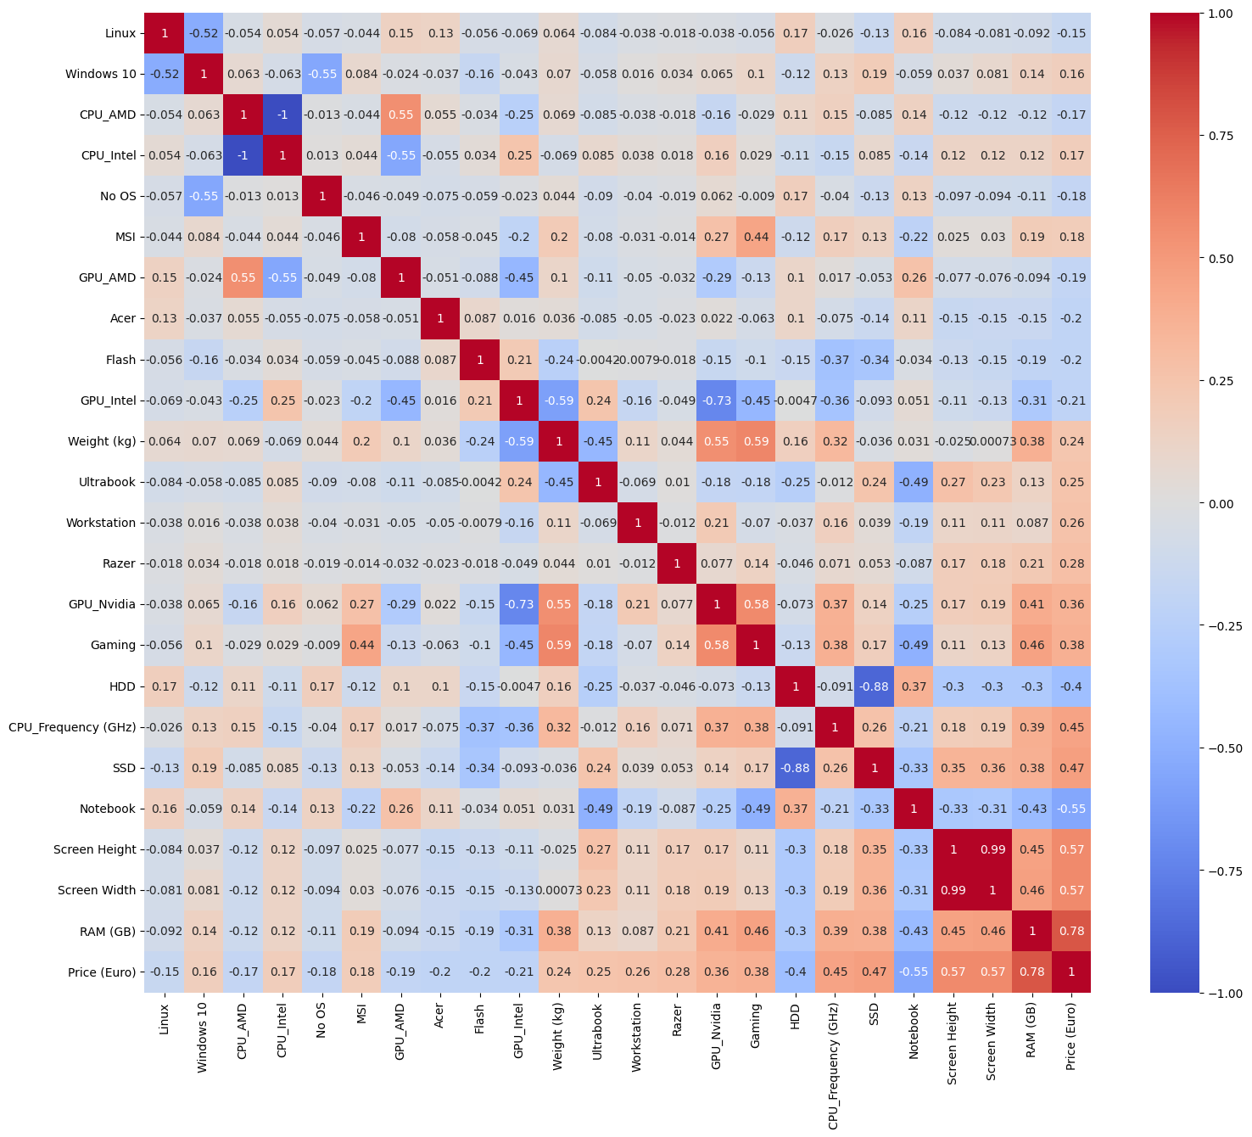

5.0 Modeling Validation and Tuning
At this stage of the project, the focus shifts from preparing the data to evaluating and improving machine learning models.
The main goal is to ensure that the models can generalize well to new, unseen data rather than simply memorizing the training dataset.
To achieve this, we used K-Fold Cross-Validation.
In this method, the dataset is divided into several smaller subsets called folds. During each iteration:
- One fold is used as the validation set.
- The remaining folds are used to train the model.
This process repeats until each fold has been used as the validation set once. The final evaluation metrics are then averaged across all folds, producing a more reliable estimate of model performance.
This approach reduces the risk of overfitting and ensures that results are not dependent on a single random train-test split.

Learning Curve Analysis
After cross-validation, we generated a learning curve to analyze how the model's performance changes as the training dataset grows.
The learning curve compares two values:
- Training Error
- Cross-Validation Error
These curves help us understand how the model behaves:
- If training error is low but validation error is high, the model is overfitting.
- If both errors are high, the model is underfitting.
- If the curves gradually converge, the model has a good balance between bias and variance.
Bias represents errors caused by overly simple assumptions, while variance reflects how sensitive the model is to changes in the training data. Increasing model complexity usually reduces bias but increases variance.
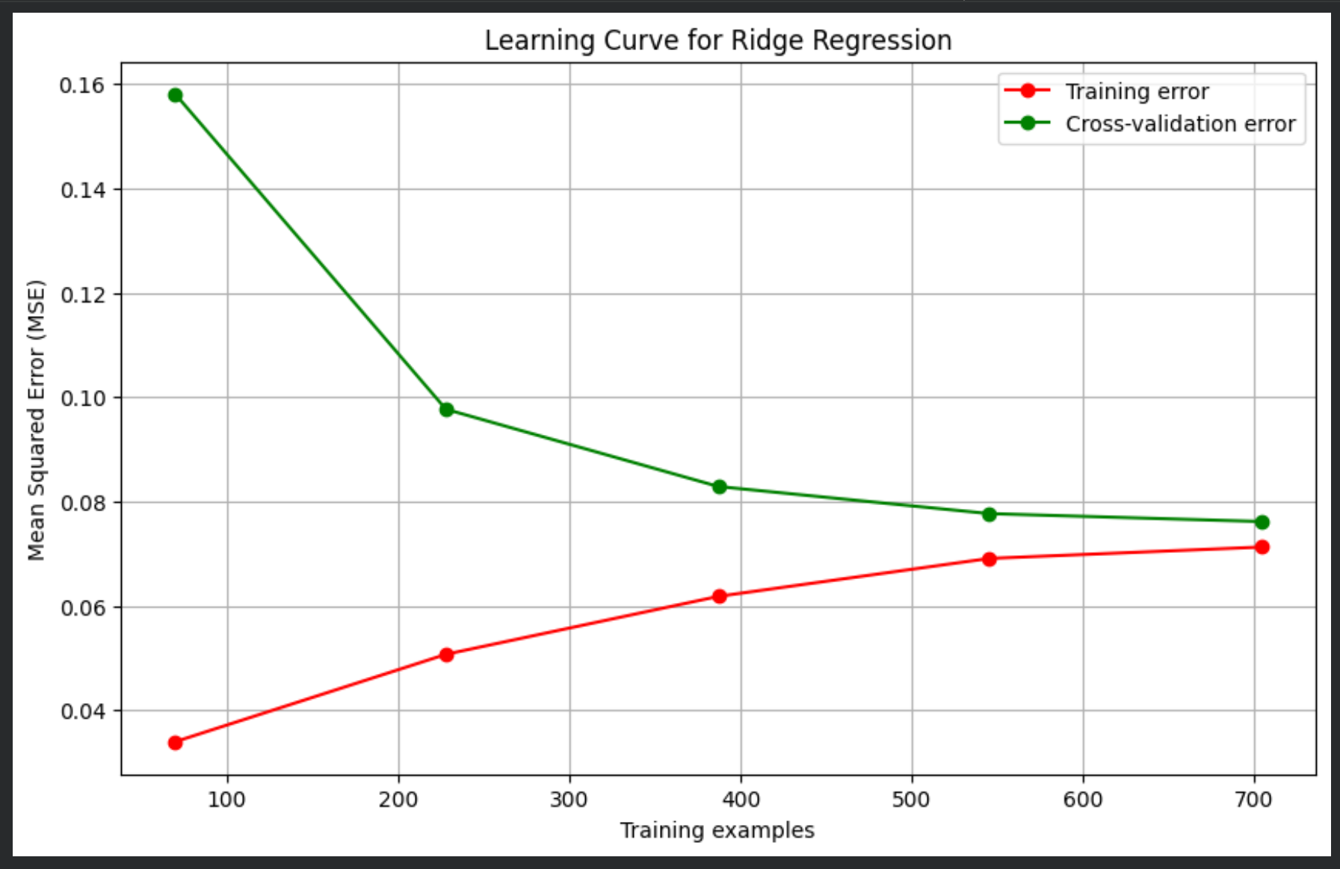

Feature Scaling
Before training the models, we standardized the numerical features using StandardScaler.
Standardization transforms each feature so that:
- Mean = 0
- Standard Deviation = 1
Scaling is important because many machine learning algorithms are sensitive to the scale of input variables.
Without scaling, large-scale variables like storage capacity might dominate the learning process, while smaller-scale variables such as CPU frequency might have very little influence.
Standardization ensures that every feature contributes fairly during model training.

Polynomial Regression (Degree 2)
Polynomial Regression was introduced to capture non-linear relationships between laptop specifications and price.
Unlike standard linear regression, polynomial regression allows the model to include additional terms such as:
- Squared features
- Interactions between variables
We selected a degree of 2, which provides enough flexibility to capture more complex relationships without dramatically increasing model complexity.
Higher polynomial degrees were avoided because they can introduce a very large number of features, increasing computational cost and the risk of overfitting.

Regularization (Ridge and Lasso)
To prevent models from becoming overly complex, we applied regularization techniques.

Ridge Regression
Ridge Regression uses L2 regularization, which adds a penalty proportional to the square of model coefficients.
This has several benefits:
- Reduces the magnitude of coefficients
- Prevents the model from relying too heavily on a single feature
- Improves generalization to new data
The strength of this penalty is controlled by the alpha (α) parameter.

Lasso Regression
Lasso Regression applies L1 regularization, which penalizes the absolute value of coefficients.
A key advantage of Lasso is that it can shrink some coefficients all the way to zero, effectively removing less important features from the model.
Because of this property, Lasso can act as an automatic feature selection method.

Decision Tree Regressor
In addition to regression models, we also evaluated a Decision Tree Regressor, which can capture complex nonlinear relationships in the data.
Decision trees work by repeatedly splitting the dataset into smaller subsets based on feature values. Each split creates a decision rule, and the final predictions are generated at the leaf nodes of the tree.
Advantages of decision trees include:
- Ability to model nonlinear patterns
- No requirement for feature scaling
- High interpretability
However, trees can easily overfit if they grow too deep. To avoid this, parameters such as maximum depth and minimum samples per split were tuned.

Multi-Model Benchmarking with Pipelines
To ensure a fair comparison between models, we used Scikit-Learn pipelines.
Pipelines combine preprocessing steps and model training into a single workflow. This ensures that transformations like feature scaling and polynomial feature generation are applied consistently during both training and validation.
The models evaluated in this benchmarking stage were:
- Linear Regression
- Polynomial Regression
- Ridge Regression
- Lasso Regression
- Decision Tree Regressor
All models were evaluated using 5-Fold Cross-Validation with the following metrics:
- Mean Absolute Error (MAE)
- Root Mean Squared Error (RMSE)
- R² Score
Using the same evaluation framework for every model ensures that performance comparisons are fair and reliable.

6.0 Model Evaluation and Comparison
After training the models, their performance was compared using multiple regression evaluation metrics.

Evaluation Metrics
R² Score
This metric measures how well the model explains the variation in laptop prices. Values closer to 1 indicate stronger predictive performance.
Mean Absolute Error (MAE)
MAE calculates the average difference between predicted prices and actual prices. Lower values indicate better accuracy.
Root Mean Squared Error (RMSE)
RMSE measures the square root of the average squared prediction errors. It penalizes larger prediction mistakes more strongly than MAE.
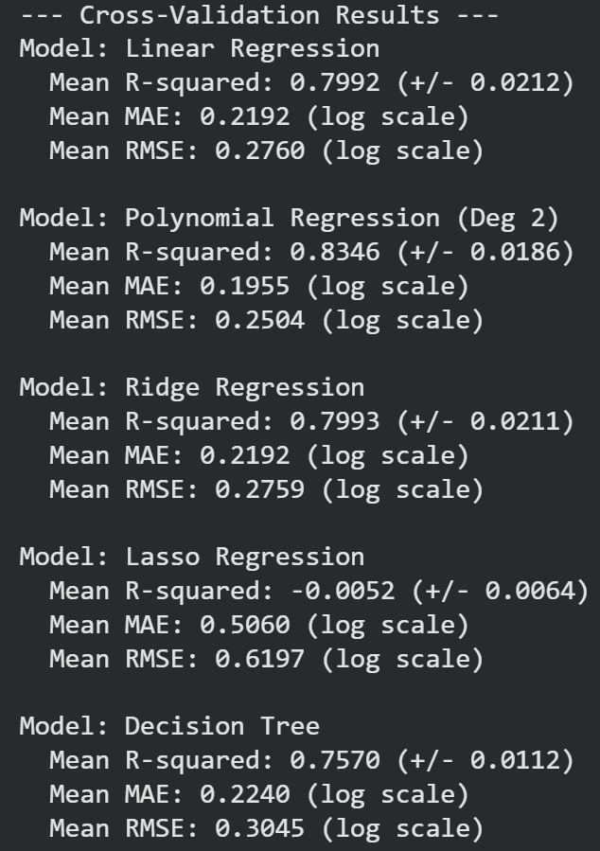

Observations
From the evaluation results we observed that:
- Linear Regression provided a solid baseline model.
- Polynomial Regression improved the ability to capture nonlinear relationships.
- Ridge Regression improved generalization by controlling coefficient size.
- Lasso Regression simplified the model by removing less important features.
- Decision Trees captured nonlinear patterns but required careful tuning to avoid overfitting.

7.0 Hyperparameter Tuning
To further improve performance, we performed hyperparameter tuning using GridSearchCV.
GridSearchCV systematically tests different combinations of model parameters and identifies the configuration that produces the best cross-validation results.

Ridge Regression Tuning
Hyperparameter tuned:
- Alpha (α) – controls the strength of regularization.
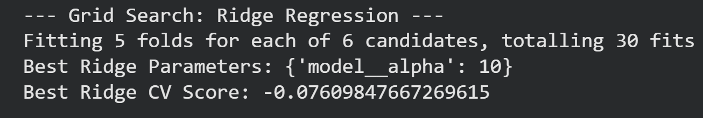

Polynomial Regression Tuning
Hyperparameter tuned:
- Polynomial Degree
Degrees tested:
- 1
- 2
- 3
- 4
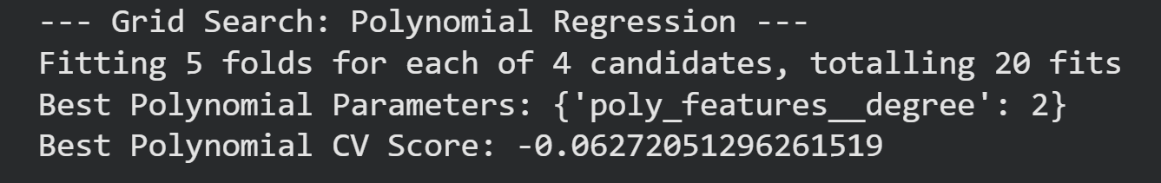

Decision Tree Tuning
Hyperparameters tuned:
- max_depth
- min_samples_split
- min_samples_leaf
These parameters help control the complexity of the tree and reduce overfitting.

8.0 Final Model Selection
After evaluating all models and tuning their parameters, the model with the best overall cross-validation performance was selected as the final model.
The selection was based on three main criteria:
- Highest R² Score
- Lowest RMSE
- Lowest MAE
We also ensured that the model demonstrated stable performance across different validation folds, confirming that it generalizes well to unseen data.
